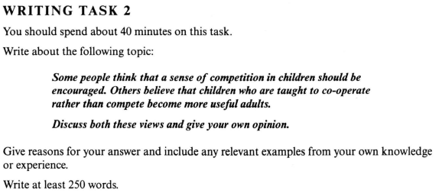

Compete or Cooperate

Nowadays parents become care more and more about how well socialised their children are and how exceptional they will be when they grow up. There are two schools of them. Many think that it is necessary for children to be competitive. While others insist that cooperation must the priority when these youths work together.

First of all, to be competitive is definitely the key factor for a successful career when facing stiff competition. Presumably, children should learn how to beat anybody else before they get their fist job. Let me draw an analogy between an athelete and a worker. If you are a sportsman, you should train hard, perhaps five days a week, in order to beat all your opponents to win a medal. So does a worker. In addition, I can also draw parallels between curbs in the wild world and children in family. Curbs are always trying to beat each other in a catch-up game so that they can successfully hunt. So do the human beings’ children. Furthermore, isn’t the development of human history driven by a competitive system? It is acknowledged that the real world is ruthless so children have to learn to survive.

Whereas, some people put forward an argument that as social animals we human beings should work as a team so that children should learn how to cooperate with each other. A man is not able to do the job but a team is. Children should realise that to achieve a goal needs their friends’ help. Team spirit should be cultivated as early as possible. In many family, children are sometines selfish because they are spoiled badly. As a result, they are neither cooperative nor competitive. Teaching them to work with someone else is extremely vital in those family.

As far as I am concerned, both of them are equivalent to each other. It is not a zero-sum game. A person can be competitive and cooperative at the same time and parents should not be polirised on this issue when they are guiding their children.